Hand Written Digit Recognition Based on Scikit-Learn (Chen-Yin Yu)

1. Preliminary Work
2. Store and Visualize the Dataset

In order to read and visualize the Mnist data, I chose to read it as numpy and save it as csv format in the entire project.

The load-mnist function returns two arrays. The first one is a n x m-dimensional NumPy array(images), where n is the number of samples (number of rows) and m is the number of features (number of columns). The training data set contains 60,000 samples and the test data set contains 10,000 samples. Each picture in the MNIST data set consists of 28 x 28 pixels, each pixel being represented by a gray value. Here, we expand the 28 x 28 pixels into a one-dimensional row vector, which is the row in the image array (784 values per line, or each row represents a single image). The second array (tag) returned by the load-mnist function contains the corresponding target variable, which is the class label of the handwritten number (integer 0-9).

Once the dataset is saved as a CSV file, we can reload them into the program using NumPy's ‘genfromtxt’ function.

1. Read the Dataset

Use the " model-selection -train-test-split" statement when randomly dividing the training set and the test set. It commonly used in cross-validation, the function is to randomly select train data and test data from the sample.

1. Save the Print Statement in a Log file

Python's logging module provides a common logging system that can be used by third-party modules or applications. This module provides different log levels and can log in different ways, such as files, HTTP GET/POST, SMTP, Socket, etc., and even implement specific logging methods.

1. Core algorithm
2. Linear Support Vector Matrix

Svm is a two-class classifier, that is, it only answers questions that belong to a positive or negative class. The problems to be solved in reality are often multiple types of problems, such as text classification, such as digital recognition.

The learning of svm is actually to find the separation hyperplane, which is to solve the Lagrange factor in the above formula. The ai is the Lagrange factor and N is the number of samples.

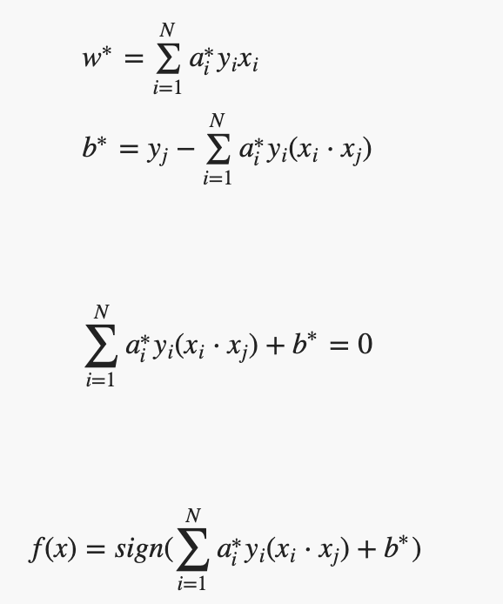

Figure. The Simple SVM model Function

The dual problem of introducing the slack variable is very different from the dual problem that is not introduced. Only the range of the Lagrangian factor ai is different. Ai ≥ 0 is not introduced into the slack variable, and 0 ≤ ai ≤ C is introduced. The slack variable is eliminated in the mathematical transformation.

Figure. The two types of samples cannot be completely separated

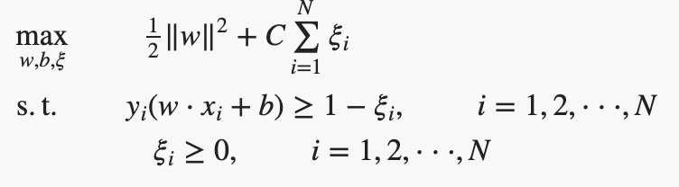

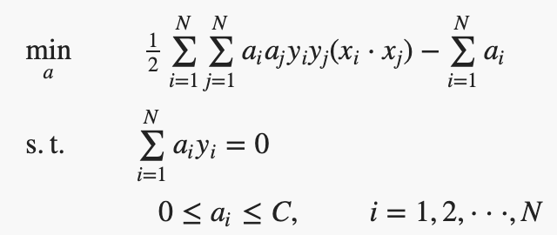

Figure. Relaxation variable make the Function Change

2）Nonlinear SVM

Sometimes our data cannot be separated by linear functions, but nonlinearity can be divided. So after a certain mathematical mapping, the data becomes linearly divided.

Let χ be the input space, specifying a mapping function φ(x). If for all x, z∈χ, the kernel function K(x, z) is satisfied. K(x,z)=φ(x)⋅φ(z). Where φ(x) ⋅ φ(z) is the inner product. With a kernel function, you can talk about data xi mapping to higher dimensions, even infinite dimensions.





Figure. Replace the minimized objective function in the dual problem with a kernel function

3) According to “**clf = svm.SVC**” the parameters are meaning:

**C**: The penalty coefficient C, C of the objective function is larger, the higher the accuracy rate is tested for the training set, but the weaker the generalization ability is, the smaller the C value is, the less the penalty for misclassification is, the fault tolerance is allowed, and the generalization ability is stronger.

**Shrinking**: helps to calculate the effect

**Verbose**: show details... is to allow redundant output

**Coef0**: constant term of the kernel function, useful for poly and sigmoid kernel functions

**Degree**: the dimension of the polynomial poly kernel function, the default is 3, other kernel functions will ignore

**Gamma**: not clear, but the effect is obvious after tuning; kernel function parameters of rbf, poly and sigmoid

**Tol**: the error value of the stop training, the default is 1e-3

1. Result Analysis
2. Confusion Matrix

When it comes to classification problems, we often need to analyze the experimental results by visualizing the confusion matrix to get the reference ideas.

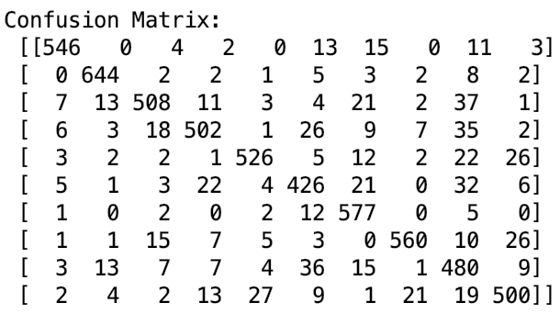

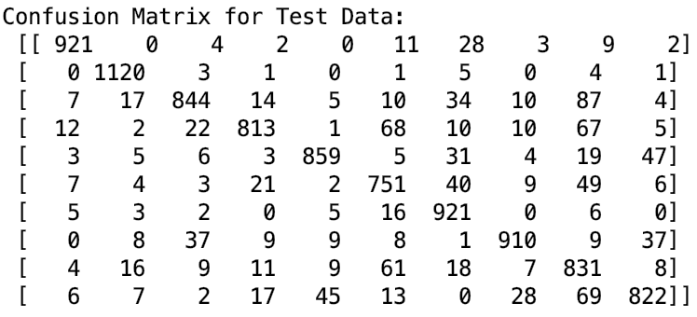

Linear Support Vector Classification Accuracy of Classifier on Train Images: 0.869

Linear Support Vector Classification Accuracy of Classifier on Test Images: 0.8742

Support Vector Classification Accuracy of Classifier on Train Images: 0.9773333333333334

Support Vector Classification Accuracy of Classifier on Test Images: 0.9771

1. GGplot

